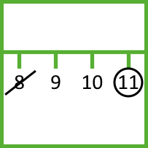

This game starts with a 0 to 20 number line.
Player 1 picks two numbers, crosses them out and circles either their sum or their difference. The crossed out numbers can’t be used again.
Player 2 crosses out the circled number and another number, and again circles either their sum or their difference.
The winner is the person who stops their opponent from being able to take a turn!
nrich.maths.org
Strike it Out

